

Міністерство освіти і науки України

Національний технічний університет України «КПІ

імені Ігоря Сікорського»

Факультет інформатики та обчислювальної техніки

Кафедра інформатики та програмної інженерії

**ЗВІТ**

лабораторної роботи №3

з дисципліни «Моделювання систем»

Перевірила:

Дифучина О. Ю.

Виконав:

Студент Гр. ІП-01

Пашковський Є. С.

Київ 2023

Завдання

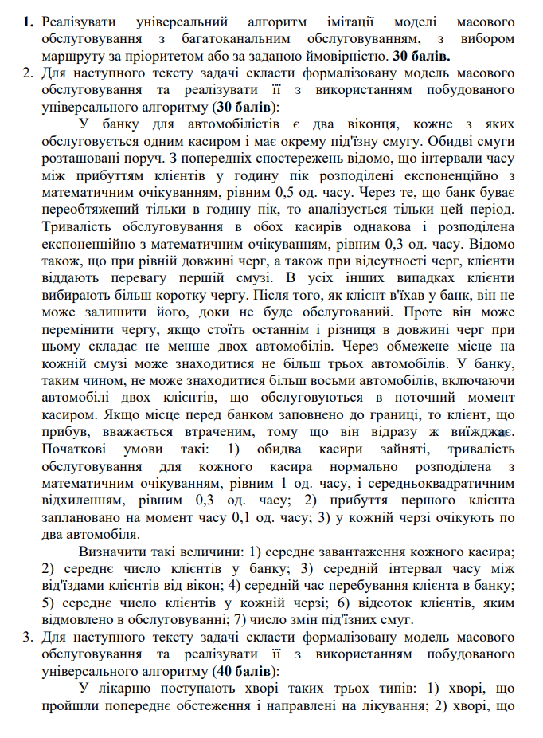

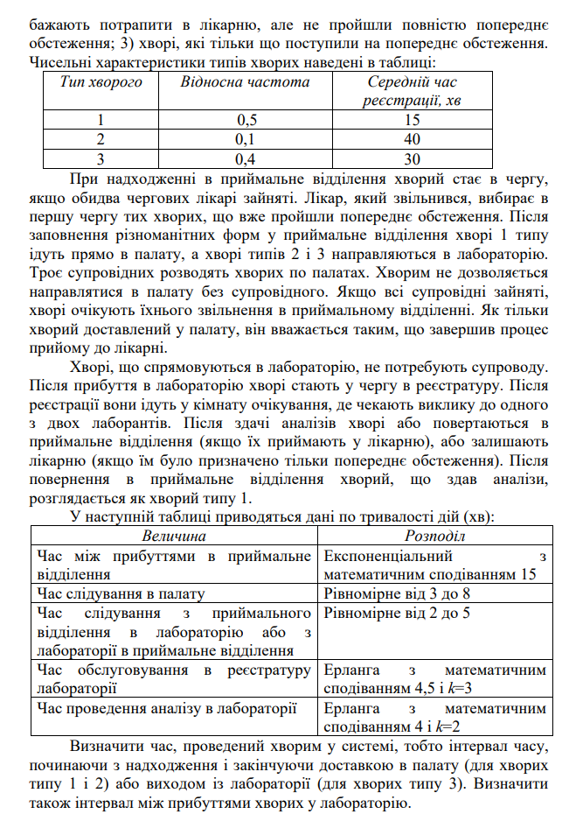

Хід роботи

Формалізовані моделі для виконання задвань:

1.

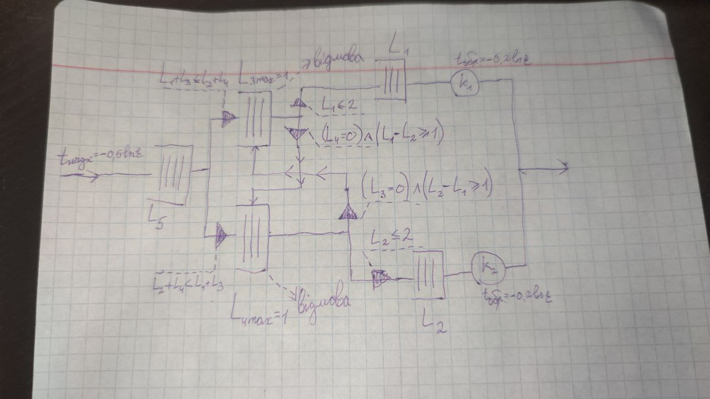

2.

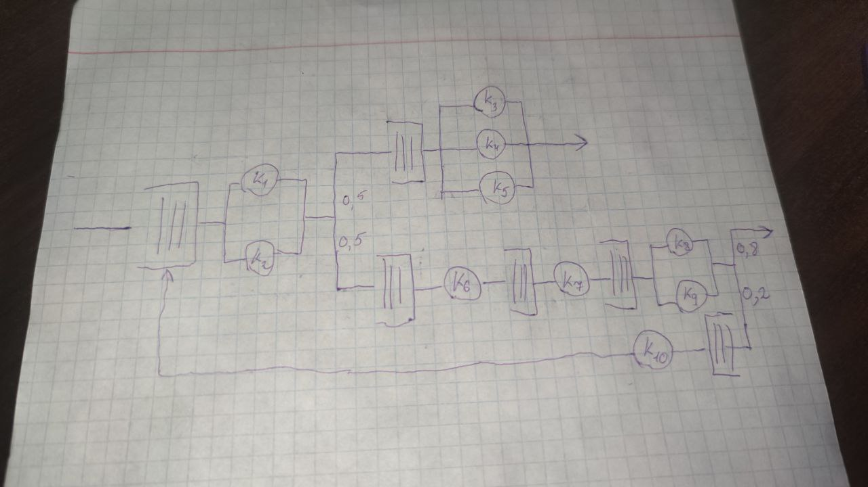

Код для виконання завдання:

// index.ts

import BankClient from './BankClient';

import BlockingElement from './BlockingElement';

import Create from './Create';

import CustomRandom from './CustomRandom';

import Distribution from './Distribution';

import Model from './Model';

import Patient, { PatientType } from './Patient';

import PriorityQueue from './PriorityQueue';

import Process from './Process';

import Queue from './Queue';

const runTest = () => {

  const create = new Create(2);

  const p1 = new Process('p1', 1);

  const p2 = new Process('p2', 1);

  const p3 = new Process('p3', 1);

  const q1 = new Queue('q1', 2);

  const q2 = new Queue('q2', 2);

  const q3 = new Queue('q3', 3);

  const b1 = new BlockingElement('b1', (_obj, t) => t < 500);

  create.setDistribution(Distribution.EXPONENTIAL);

  p1.setDistribution(Distribution.EXPONENTIAL);

  p2.setDistribution(Distribution.EXPONENTIAL);

  p3.setDistribution(Distribution.EXPONENTIAL);

  create.setNextElements([q1]);

  q1.setNextElements([p1]);

  p1.setNextElements([q2]);

  q2.setNextElements([b1, q3]);

  b1.setNextElements([p2]);

  // p2.setNextElements([q3]);

  q3.setNextElements([p3]);

  const model = new Model([create, p1, p2, p3, q1, q2, q3, b1]);

  model.simulate(1000);

};

const runTask2Min = () => {

  const create = new Create(0.2);

  create.setDistribution(Distribution.EXPONENTIAL);

  const p1 = new Process('p1', 0.3);

  p1.setDistribution(Distribution.EXPONENTIAL);

  const p2 = new Process('p2', 0.3);

  p2.setDistribution(Distribution.EXPONENTIAL);

  const q1 = new Queue('q1', 3);

  const q2 = new Queue('q2', 3);

  const b1 = new BlockingElement('b1', () => q1.getLength() > q2.getLength());

  const b2 = new BlockingElement('b2', () => q2.getLength() >= q1.getLength());

  create.setNextElements([b1, b2]);

  b1.setNextElements([q1]);

  b2.setNextElements([q2]);

  q1.setNextElements([p1]);

  q2.setNextElements([p2]);

  const model = new Model([create, p1, p2, q1, q2, b1, b2]);

  model.simulate(1000);

};

const runTask2 = () => {

  const create = new Create(0.5, (t) => new BankClient(t));

  create.setDistribution(Distribution.EXPONENTIAL);

  const outputIntervals: number[] = [];

  const meanGeneralProcessingIntervals: number[] = [];

  let prevOutputT = 0;

  const p1 = new Process<BankClient>('p1', 0.3, (obj) => {

    if (prevOutputT) outputIntervals.push(p1.getCurrentT() - prevOutputT);

    prevOutputT = p1.getCurrentT();

    meanGeneralProcessingIntervals.push(p1.getCurrentT() - obj.bankEnterT);

    return obj;

  });

  p1.setDistribution(Distribution.EXPONENTIAL);

  const p2 = new Process<BankClient>('p2', 0.3, (obj) => {

    if (prevOutputT) outputIntervals.push(p2.getCurrentT() - prevOutputT);

    prevOutputT = p2.getCurrentT();

    meanGeneralProcessingIntervals.push(p2.getCurrentT() - obj.bankEnterT);

    return obj;

  });

  p2.setDistribution(Distribution.EXPONENTIAL);

  const qStart = new Queue<BankClient>('qStart');

  const q1 = new Queue<BankClient>('q1');

  const q2 = new Queue<BankClient>('q2');

  const q3 = new Queue<BankClient>('q3', 1);

  const q4 = new Queue<BankClient>('q4', 1);

  const b1 = new BlockingElement<BankClient>(

    'b1',

    () => q1.getLength() + q3.getLength() > q2.getLength() + q4.getLength()

  );

  const b2 = new BlockingElement<BankClient>(

    'b2',

    () => q2.getLength() + q4.getLength() >= q1.getLength() + q3.getLength()

  );

  const b3 = new BlockingElement<BankClient>(

    'b3',

    () => !(q4.getLength() === 0 && q1.getLength() - q2.getLength() >= 1)

  );

  const b4 = new BlockingElement<BankClient>(

    'b4',

    () => !(q3.getLength() === 0 && q2.getLength() - q1.getLength() >= 1)

  );

  const b5 = new BlockingElement<BankClient>('b5', () => q1.getLength() === 2);

  const b6 = new BlockingElement<BankClient>('b6', () => q2.getLength() === 2);

  create.setNextElements([qStart]);

  qStart.setNextElements([b1, b2]);

  b1.setNextElements([q3]);

  q3.setNextElements([b3, b5]);

  b3.setNextElements([q4]);

  b5.setNextElements([q1]);

  q1.setNextElements([p1]);

  b2.setNextElements([q4]);

  q4.setNextElements([b4, b6]);

  b4.setNextElements([q3]);

  b6.setNextElements([q2]);

  q2.setNextElements([p2]);

  const t = 1000;

  const model = new Model([

    create,

    p1,

    p2,

    qStart,

    q1,

    q2,

    q3,

    q4,

    b1,

    b2,

    b3,

    b4,

    b5,

    b6,

  ]);

  model.simulate(t);

  console.log('\nTask results:');

  console.log(`cashier 1 mean work time: ${p1.getTotalWorkTime() / t}`);

  console.log(`cashier 2 mean work time: ${p2.getTotalWorkTime() / t}`);

  console.log(

    `mean clients in bank: ${

      (q1.getMeanQueueLength() +

        q2.getMeanQueueLength() +

        q3.getMeanQueueLength() +

        q4.getMeanQueueLength()) /

      t

    }`

  );

  console.log(

    `mean output interval: ${

      outputIntervals.reduce((acc, el) => acc + el, 0) / outputIntervals.length

    }`

  );

  console.log(

    `mean client time in bank: ${

      meanGeneralProcessingIntervals.reduce((acc, el) => acc + el, 0) /

      meanGeneralProcessingIntervals.length

    }`

  );

  console.log(

    `failure rate: ${

      q3.getFailuresCount() / (q3.getQuantity() + q3.getFailuresCount()) +

      q4.getFailuresCount() / (q4.getQuantity() + q4.getFailuresCount())

    }`

  );

  console.log(`line change count: ${b3.getQuantity() + b4.getQuantity()}`);

};

const runTask3 = () => {

  let lastLabInputT = 0;

  const labInputIntervals: number[] = [];

  const processingIntervals: number[] = [];

  const create = new Create(15, (t) => {

    const rand = Math.random();

    const type =

      rand < 0.5

        ? PatientType.ONE

        : rand < 0.6

        ? PatientType.TWO

        : PatientType.THREE;

    return new Patient(type, t);

  });

  create.setDistribution(Distribution.EXPONENTIAL);

  const doctorDelayFunc = (obj: Patient) =>

    obj.type === PatientType.ONE ? 15 : obj.type === PatientType.TWO ? 40 : 30;

  const attendantDelayFunc = () => Math.random() * 5 + 3;

  const labTransferDelayFunc = () => Math.random() * 3 + 2;

  const labRegisterDelayFunc = () => CustomRandom.generateErlang(4.5, 3);

  const labAssistantDelayFunc = () => CustomRandom.generateErlang(4, 2);

  const attendantProcessingFunc = (obj: Patient, t: number) => {

    processingIntervals.push(t - obj.enterT);

    return obj;

  };

  const labAssistantProcessingFunc = (obj: Patient, t: number) => {

    if (obj.type === PatientType.THREE)

      processingIntervals.push(t - obj.enterT);

    return obj;

  };

  const doctor1 = new Process<Patient>('doctor1[p]', doctorDelayFunc);

  const doctor2 = new Process<Patient>('doctor2[p]', doctorDelayFunc);

  const attendant1 = new Process<Patient>(

    'attendant1[p]',

    attendantDelayFunc,

    attendantProcessingFunc

  );

  const attendant2 = new Process<Patient>(

    'attendant2[p]',

    attendantDelayFunc,

    attendantProcessingFunc

  );

  const attendant3 = new Process<Patient>(

    'attendant3[p]',

    attendantDelayFunc,

    attendantProcessingFunc

  );

  const transferToLabProcess = new Process<Patient>(

    'transfer to lab[p]',

    labTransferDelayFunc,

    (obj) => {

      if (lastLabInputT)

        labInputIntervals.push(

          transferToLabProcess.getCurrentT() - lastLabInputT

        );

      lastLabInputT = transferToLabProcess.getCurrentT();

      return obj;

    }

  );

  const labRegister = new Process<Patient>(

    'lab register[p]',

    labRegisterDelayFunc

  );

  const labAssistant1 = new Process<Patient>(

    'lab assistan1[p]',

    labAssistantDelayFunc,

    labAssistantProcessingFunc

  );

  const labAssistant2 = new Process<Patient>(

    'lab assistan2[p]',

    labAssistantDelayFunc,

    labAssistantProcessingFunc

  );

  const transferFromLabProcess = new Process<Patient>(

    'transfer from lab[p]',

    labTransferDelayFunc,

    (patient) => {

      patient.type = PatientType.ONE;

      return patient;

    }

  );

  const reception = new PriorityQueue<Patient>('reception[q]', (obj) =>

    obj.type === PatientType.ONE ? 1 : 0

  );

  const attendantWaiting = new Queue<Patient>('attendant waiting[q]');

  const toLabTransfering = new Queue<Patient>('to lab transfering[q]');

  const labReception = new Queue<Patient>('lab reception[q]');

  const labWaitingRoom = new Queue<Patient>('lab waiting room[q]');

  const fromLabTransfering = new Queue<Patient>('from lab transfering[q]');

  const labExit = new Queue<Patient>('lab exit[q]');

  const type1Block = new BlockingElement<Patient>(

    'type1Block',

    (obj) => obj.type !== PatientType.ONE

  );

  const type23Block = new BlockingElement<Patient>(

    'type23Block',

    (obj) => obj.type !== PatientType.TWO && obj.type !== PatientType.THREE

  );

  const type2Block = new BlockingElement<Patient>(

    'type2Block',

    (obj) => obj.type !== PatientType.TWO

  );

  const type13Block = new BlockingElement<Patient>(

    'type13Block',

    (obj) => obj.type !== PatientType.ONE && obj.type !== PatientType.THREE

  );

  create.setNextElements([reception]);

  reception.setNextElements([doctor1, doctor2]);

  doctor1.setNextElements([type1Block, type23Block]);

  doctor2.setNextElements([type1Block, type23Block]);

  type1Block.setNextElements([attendantWaiting]);

  attendantWaiting.setNextElements([attendant1, attendant2, attendant3]);

  type23Block.setNextElements([toLabTransfering]);

  toLabTransfering.setNextElements([transferToLabProcess]);

  transferToLabProcess.setNextElements([labReception]);

  labReception.setNextElements([labRegister]);

  labRegister.setNextElements([labWaitingRoom]);

  labWaitingRoom.setNextElements([labAssistant1, labAssistant2]);

  labAssistant1.setNextElements([type2Block, type13Block]);

  labAssistant2.setNextElements([type2Block, type13Block]);

  type13Block.setNextElements([labExit]);

  type2Block.setNextElements([fromLabTransfering]);

  fromLabTransfering.setNextElements([transferFromLabProcess]);

  transferFromLabProcess.setNextElements([reception]);

  const model = new Model([

    create,

    doctor1,

    doctor2,

    attendant1,

    attendant2,

    attendant3,

    transferToLabProcess,

    labRegister,

    labAssistant1,

    labAssistant2,

    transferFromLabProcess,

    reception,

    attendantWaiting,

    toLabTransfering,

    labReception,

    labWaitingRoom,

    fromLabTransfering,

    labExit,

    type1Block,

    type23Block,

    type2Block,

    type13Block,

  ]);

  model.simulate(10000);

  console.log('\nTask results:');

  console.log(

    `Mean processing time: ${

      processingIntervals.reduce((acc, el) => acc + el, 0) /

      processingIntervals.length

    }`

  );

  console.log(

    `Mean lab input interval: ${

      labInputIntervals.reduce((acc, el) => acc + el, 0) /

      labInputIntervals.length

    }`

  );

};

// runTest();

// runTask2();

runTask3();

// Element.ts

import CustomRandom from './CustomRandom';

import Distribution from './Distribution';

import ModelObject from './ModelObject';

export default abstract class Element<T extends ModelObject> {

  private static nextId = 0;

  protected id = Element.getNextId();

  private currentT = 0;

  protected nextT = 0;

  protected quantity = 0;

  protected nextElementsOptions:

    | { type: 'simple'; elements: Element<T>[] }

    | {

        type: 'possibilities';

        options: { element: Element<T>; probability: number }[];

      } = { type: 'simple', elements: [] };

  private delayFunction?: (obj: T) => number;

  constructor(

    protected name = '',

    private distribution: Distribution = Distribution.STATIC,

    private delayMean = 0,

    private delayVariance = 0

  ) {}

  public static getNextId() {

    return this.nextId++;

  }

  public getDelay(obj: T): number {

    if (this.delayFunction) return this.delayFunction(obj);

    switch (this.distribution) {

      case Distribution.NORMAL:

        return CustomRandom.generateNormal(

          Math.sqrt(this.delayVariance),

          this.delayMean

        );

      case Distribution.EXPONENTIAL:

        return CustomRandom.generateExponential(1 / this.delayMean);

      case Distribution.UNIFORM:

        return CustomRandom.generateUniform() * 2 * this.delayMean;

      case Distribution.STATIC:

      default:

        return this.delayMean;

    }

  }

  public inAction(obj: T) {}

  public outAction() {

    this.quantity++;

  }

  public setNextElements(elements: Element<T>[]) {

    this.nextElementsOptions = { type: 'simple', elements };

  }

  public setNextPossibleElements(

    options: { element: Element<T>; probability: number }[]

  ) {

    if (options.reduce((acc, el) => acc + el.probability, 0) !== 1)

      throw new Error('Sum of possibilities should equal 1');

    this.nextElementsOptions = { type: 'possibilities', options };

  }

  public getNextElement(obj: T) {

    if (this.nextElementsOptions.type === 'simple') {

      for (const element of this.nextElementsOptions.elements) {

        if (element.isReadyForIn(obj)) return element;

      }

      return;

    }

    const rand = Math.random();

    let sum = 0;

    for (const { element, probability } of this.nextElementsOptions.options) {

      sum += probability;

      if (rand < sum) return element;

    }

    return;

  }

  public getClosestNextElement(obj: T) {

    let closestElement: Element<T> | undefined = undefined;

    const elements = this.getNextElementsOptions();

    for (const element of elements) {

      if (

        element.isReadyForIn(obj) &&

        (!closestElement || element.nextT < closestElement.nextT)

      ) {

        closestElement = element;

      }

    }

    return closestElement;

  }

  public setCurrentT(t: number) {

    this.currentT = t;

  }

  public setNextT(t: number) {

    this.nextT = t;

  }

  public getCurrentT() {

    return this.currentT;

  }

  public getNextT() {

    return this.nextT;

  }

  public getQuantity() {

    return this.quantity;

  }

  public printResult() {

    console.log(`${this.name}[${this.id}] quantity = ${this.quantity}`);

  }

  public printInfo() {

    console.log(

      `${this.name}[${this.id}] quantity = ${this.quantity} tnext= ${this.nextT}`

    );

  }

  public setDistribution(distribution: Distribution) {

    this.distribution = distribution;

  }

  public setDelayFunction(func: (obj: T) => number) {

    this.delayFunction = func;

  }

  public getIdentifier() {

    return `${this.name}[${this.id}]`;

  }

  public doStatistics(delta: number) {}

  public isReadyForIn(obj: T) {

    return true;

  }

  public getNextElementsOptions() {

    return this.nextElementsOptions.type === 'simple'

      ? this.nextElementsOptions.elements

      : this.nextElementsOptions.options.map((option) => option.element);

  }

}

enum Distribution {

  EXPONENTIAL = 'exponential',

  NORMAL = 'normal',

  UNIFORM = 'uniform',

  STATIC = 'static',

}

export default Distribution;

import generateRandomOne from '../../lab1/src/server/generateRandomOne';

import generateRandomThree from '../../lab1/src/server/generateRandomThree';

import generateRandomTwo from '../../lab1/src/server/generateRandomTwo';

export default class CustomRandom {

  public static generateNormal(o: number, a: number) {

    return generateRandomTwo(o, a);

  }

  public static generateExponential(lambda: number) {

    return generateRandomOne(lambda);

  }

  public static generateUniform() {

    return generateRandomThree();

  }

  public static generateErlang(a: number, k: number) {

    let multEps = 1;

    for (let i = 0; i < k; i++) {

      multEps *= Math.random();

    }

    return -Math.log(multEps) / (k * a);

  }

}

import Distribution from './Distribution';

import Element from './Element';

import ModelObject from './ModelObject';

export default class Create<T extends ModelObject> extends Element<T> {

  constructor(

    delay: number,

    private readonly createObject = (t: number) => new ModelObject() as T

  ) {

    super('create', Distribution.STATIC, delay);

  }

  public inAction(): void {

    throw new Error('Tried to call inAction on Create');

  }

  public outAction() {

    const newObj = this.createObject(this.getCurrentT());

    super.outAction();

    super.setNextT(super.getCurrentT() + super.getDelay(newObj));

    super.getNextElement(newObj)?.inAction(newObj);

  }

}

import Element from './Element';

import ModelObject from './ModelObject';

export default class BlockingElement<T extends ModelObject> extends Element<T> {

  private currentObject?: T;

  constructor(

    name: string,

    public readonly isBlocked: (obj: T, t: number) => boolean

  ) {

    super(name);

    this.setNextT(Infinity);

  }

  public inAction(obj: T): void {

    if (this.isBlocked(obj, this.getCurrentT()))

      throw new Error('Tried to perform inAction on blocked element');

    this.currentObject = obj;

    this.setNextT(this.getCurrentT());

  }

  public outAction(): void {

    if (!this.currentObject)

      throw new Error('Tried to perform outAction on unbusy blocking element');

    super.outAction();

    const nextElement = this.getNextElement(this.currentObject);

    if (this.getNextElementsOptions().length > 0 && !nextElement)

      throw new Error(

        'Tried to perform outAction on blocking element without free next element'

      );

    nextElement?.inAction(this.currentObject);

    this.currentObject = undefined;

    this.setNextT(Infinity);

  }

  public isReadyForIn(obj: T): boolean {

    const nextElement = this.getNextElement(obj);

    return (

      !this.currentObject &&

      !this.isBlocked(obj, this.getCurrentT()) &&

      !!nextElement &&

      nextElement.isReadyForIn(obj)

    );

  }

}

import ModelObject from './ModelObject';

export default class BankClient extends ModelObject {

  constructor(public readonly bankEnterT: number) {

    super();

  }

}

import Element from './Element';

import ModelObject from './ModelObject';

import Process from './Process';

import Queue from './Queue';

export default class Model<T extends ModelObject> {

  private elements: Element<T>[] = [];

  private currentT: number = 0;

  private nextT: number = 0;

  private event: number = 0;

  constructor(elements: Element<T>[]) {

    this.elements = elements;

  }

  public simulate(t: number) {

    while (this.currentT < t) {

      this.nextT = Infinity;

      for (let i = 0; i < this.elements.length; i++) {

        const element = this.elements[i];

        if (element.getNextT() < this.nextT) {

          this.nextT = element.getNextT();

          this.event = i;

        }

      }

      console.log(

        '\nIts time for event in ' +

          this.elements[this.event].getIdentifier() +

          ', time = ' +

          this.nextT

      );

      for (const element of this.elements) {

        element.doStatistics(this.nextT - this.currentT);

      }

      this.currentT = this.nextT;

      for (const element of this.elements) {

        element.setCurrentT(this.currentT);

      }

      for (const element of this.elements) {

        if (element.getNextT() === this.currentT) {

          element.outAction();

        }

      }

      this.printInfo();

    }

    this.printResult();

  }

  public printInfo() {

    for (const element of this.elements) {

      element.printInfo();

    }

  }

  public printResult() {

    console.log('\n-------------RESULTS-------------');

    for (const element of this.elements) {

      element.printResult();

      if (element instanceof Queue) {

        console.log(

          `mean length of queue = ${

            element.getMeanQueueLength() / this.currentT

          }\nfailure probability = ${

            element.getFailuresCount() /

            (element.getQuantity() + element.getFailuresCount())

          }\n`

        );

      }

      if (element instanceof Process) {

        console.log(

          `mean work time = ${element.getTotalWorkTime() / this.currentT}\n`

        );

      }

    }

  }

}

import ModelObject from './ModelObject';

export enum PatientType {

  ONE = 1,

  TWO = 2,

  THREE = 3,

}

export default class Patient extends ModelObject {

  constructor(

    public type: PatientType,

    public readonly enterT: number

  ) {

    super();

  }

}

import ModelObject from './ModelObject';

import Queue from './Queue';

export default class PriorityQueue<T extends ModelObject> extends Queue<T> {

  constructor(

    name: string,

    private readonly getPriority: (obj: T) => number,

    size?: number

  ) {

    super(name, size);

  }

  public enqueue(item: T): boolean {

    if (this.items.length === this.size) return false;

    const priority = this.getPriority(item);

    let i = this.items.length - 1;

    while (i >= 0 && priority > this.getPriority(this.items[i])) {

      i--;

    }

    this.items.splice(i + 1, 0, item);

    return true;

  }

}

import Distribution from './Distribution';

import Element from './Element';

import ModelObject from './ModelObject';

export default class Process<T extends ModelObject> extends Element<T> {

  private currentObject?: T;

  private totalWorkTime = 0;

  private prevWorkStart = 0;

  constructor(

    name: string,

    delayFunc: (obj: T) => number,

    modifyObj?: (obj: T, t: number) => T

  );

  constructor(name: string, delay: number, modifyObj?: (obj: T) => T);

  constructor(

    name: string,

    delay?: number | ((obj: T) => number),

    private readonly modifyObj: (obj: T, t: number) => T = (obj) => obj

  ) {

    const isDelayFunction = typeof delay === 'function';

    super(name, Distribution.STATIC, isDelayFunction ? 0 : delay);

    this.setNextT(Infinity);

    if (isDelayFunction) {

      this.setDelayFunction(delay);

    }

  }

  public inAction(obj: T): void {

    this.currentObject = obj;

    this.setNextT(this.getCurrentT() + this.getDelay(obj));

    this.prevWorkStart = this.getCurrentT();

  }

  public outAction(): void {

    super.outAction();

    if (!this.currentObject)

      throw new Error('Tried to perform outAction on unbusy process');

    const modifiedObject = this.modifyObj(

      this.currentObject,

      this.getCurrentT()

    );

    const nextElement = this.getNextElement(modifiedObject);

    if (this.getNextElementsOptions().length > 0 && !nextElement)

      throw new Error(

        'Tried to perform outAction on process without free next element'

      );

    nextElement?.inAction(modifiedObject);

    this.currentObject = undefined;

    this.setNextT(Infinity);

    this.totalWorkTime += this.getCurrentT() - this.prevWorkStart;

  }

  public isBusy() {

    return !!this.currentObject;

  }

  public getTotalWorkTime() {

    return this.totalWorkTime;

  }

  public isReadyForIn(): boolean {

    return !this.isBusy();

  }

}

import Element from './Element';

import ModelObject from './ModelObject';

export default class Queue<T extends ModelObject> extends Element<T> {

  protected items: T[] = [];

  private failuresCount = 0;

  private meanQueueLength = 0;

  constructor(

    name: string,

    public readonly size: number = Infinity

  ) {

    super(name);

    this.setNextT(Infinity);

  }

  public enqueue(item: T) {

    if (this.items.length === this.size) return false;

    this.items.push(item);

    return true;

  }

  public dequeue() {

    return this.items.shift();

  }

  public getLength() {

    return this.items.length;

  }

  public inAction(obj: T): void {

    if (!this.enqueue(obj)) this.failuresCount++;

  }

  public outAction(): void {

    const obj = this.dequeue();

    if (!obj) throw new Error('Tried to perfrom outAction on empty queue');

    const nextElement = this.getNextElement(obj);

    if (this.getNextElementsOptions().length > 0 && !nextElement)

      throw new Error(

        'Tried to perform outAction on queue without free next element'

      );

    super.outAction();

    nextElement?.inAction(obj);

  }

  public getNextT() {

    const closestNextElement = this.getClosestNextElement(this.items[0]);

    return this.items.length === 0 || !closestNextElement

      ? Infinity

      : closestNextElement.isReadyForIn(this.items[0])

      ? this.getCurrentT()

      : closestNextElement.getNextT();

  }

  public doStatistics(delta: number): void {

    this.meanQueueLength += this.items.length * delta;

  }

  public printInfo() {

    console.log(

      `${this.name}[${this.id}] quantity = ${this.quantity} tnext = ${this.nextT} length = ${this.items.length}`

    );

  }

  public getFailuresCount() {

    return this.failuresCount;

  }

  public getMeanQueueLength() {

    return this.meanQueueLength;

  }

}

Результати роботи коду:

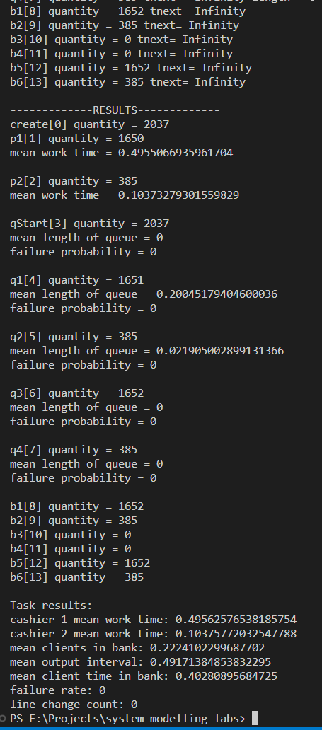

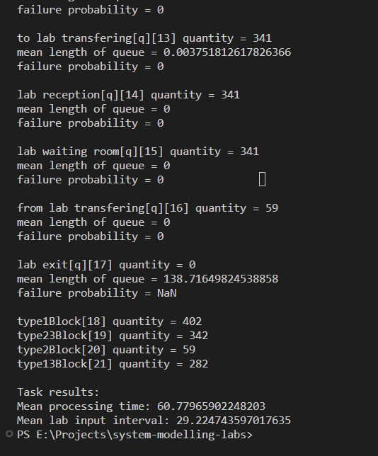

Висновки: під час виконання цього завдання було побудовано декілька формалізованих моделей масового обслуговування та протестовано для вказаних задач та задля отримання певних метрик.